Health and Safety Policy

September 23

UK

THE POLICY

September 23
Status: Version 1

Southbank International School Kensington ("the School")
HEALTH AND SAFETY POLICY
PART ONE - STATEMENT OF INTENT

INTRODUCTION
The school believes that ensuring the health and safety of staff, pupils and visitors and positively promoting health and safety is essential to the success of the school.

We are committed to:

- Providing a safe and healthy working and learning environment on and off site
- Preventing accidents and work related ill health
- Providing safe premises (including access and egress), plant and equipment
- Maintaining safe systems of work among staff (including teaching and non-teaching staff, peripatetic workers and students undertaking work experience) and pupils
- Assessing and controlling risks from curriculum and non-curriculum work activities
- Providing a safe means of use, handling, storage and transportation of articles and substances
- Formulating effective procedures for use in case of fire and/or the need for emergency evacuation of the school
- Providing adequate information, instruction, training and supervision to staff and pupils
- Consulting with staff, pupils and their representatives on health and safety matters
- Setting targets and objectives regarding health and safety performance to develop a culture of continuous improvement
- The regular monitoring and review of health and safety procedures and systems (to include risk assessments, accident records and health and safety related issues and complaints etc)
- Ensuring adequate welfare facilities exist throughout the school
- Ensuring adequate resources are made available for health and safety issues, so far as is reasonably practicable.
The school will establish a Health and Safety Management System to ensure the above commitments can be met. Cognita Schools Ltd, the Principal, staff and pupils will play their part in its implementation.

NAME: Michael Drake  Chief Executive Europe | 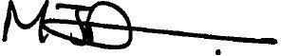
NAME: Siobhan McGrath  DATE:29.11.23 | Insert SIGNATURE:  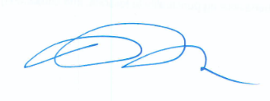

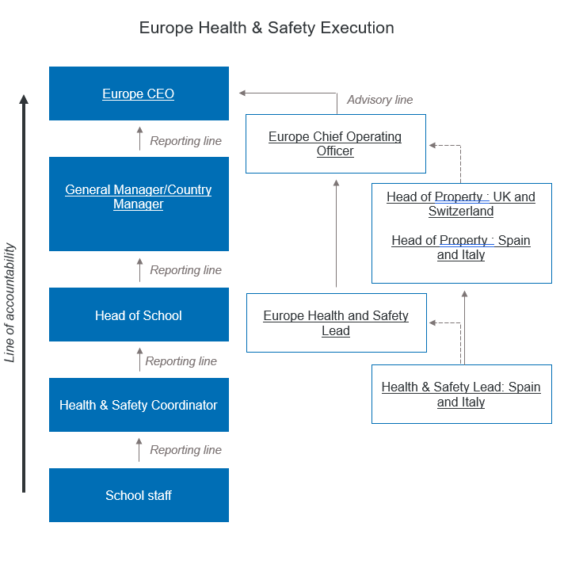

PART TWO - ORGANISATION

INTRODUCTION
The Board of Directors of Cognita Schools Ltd are responsible for ensuring the implementation of this Health and Safety Policy.

The Directors delegate responsibility for health and safety management to the General Managers and to their Principal.

In order to ensure compliance with the law and the school’s Statement of Intent the Principal will arrange appropriate delegation of health and safety management issues as detailed in this part of the Policy.

PRNCIPAL WILL ENSURE:

- The promotion of a health and safety culture within the school and on off-site visits in order to prevent accidents, work-related ill health and damage to property.
- That a clear written health and safety policy is developed, implemented and communicated in accordance with legal obligations, relevant HSE and DfE and other appropriate guidance and guidance from Cognita.
- The effective management of health, safety and welfare of staff, pupils, contractors, visitors and others so far as is reasonably practicable. This policy applies to all pupils, including those in the Early Years.
- Adequate control of health and safety risks arising out of the school's activities.
- The provision and maintenance of safe premises, plant and equipment.
- Responsibilities for health, safety and welfare are allocated to specific people and those persons are formally informed of these responsibilities.
- Persons to whom health and safety responsibilities are delegated are competent to do their tasks i.e. that they have sufficient experience, knowledge and training to perform the tasks required of them and have sufficient time and resources to undertake the role.
- The provision of adequate information, instruction, supervision and training for staff and pupils and others such as contractors, where appropriate.
- The establishment of a school H&S Committee which is representative of the operation and structure of the school and which meets at least Termly.
- That arrangements are in place for the effective consultation with staff, nominated trade union representatives and pupils regarding health and safety matters.
- Clear procedures are created for risk assessment, the development of safe working practices and reporting of accidents, incidents, dangerous occurrences and near misses.
- The formulation of effective procedures for use in case of fire and/or the need for emergency evacuation of the school.
- Sufficient funds are set aside for health and safety management in accordance with the Statement of Intent.
- The school complies with its reporting and record keeping obligations.
- Accidents, incidents, absence and complaints pertaining to matters of health and safety are properly investigated, if required, and that the school co-operates with the relevant enforcement agencies such as the HSE, local authority and fire authority, if required.
- Health and safety performance is measured both actively and reactively and measures are put in place to monitor the effectiveness of the health and safety arrangements in controlling identified risks.
- The school’s health and safety policy is reviewed annually and in light of any significant change throughout the school academic year. Performance is monitored regularly and reports on the health and safety performance of the school is prepared for Head of H&S Europe.

SCHOOL H&S CO-ORDINATOR WILL ENSURE:

- The promotion of a positive health and safety culture within the School.
- The implementation of a clear, written School Health and Safety Policy that has been developed from the approved Cognita (UK) model policy and is communicated and regularly updated in accordance with legal obligations (alongside other appropriate guidance and updates from the Cognita Group).
- Maintained liaison with other specialist health, safety and fire safety roles appointed within the School, to co-ordinate compliance actions and provide a central point of contact.

- The dissemination of information relevant to health and safety compliance ensuring all compliance duty holders and other key parties within the School are included.
- The co-ordination of the School’s H&S Meetings, ensuring these are conducted in accordance with the Terms of Reference for school H&S committee.
- Central co-ordination and access as a key point of contact for any accident, incident or near miss occurrence. Ensuring thorough investigation, review, recording of information and escalation has been conducted and final actions closed out
- Liaison with all School Departments to ensure risk assessments are produced for tasks/activities within such areas, with information provided to relevant parties and regular review undertaken.
- Support as the key contact in order to co-operate with any enforcement agency such as the HSE, UKHPA, local authority and fire authority, as required.
- Systems are established to allow staff (both teaching and non-teaching) to receive adequate information, supervision and training (both induction training and ongoing training) in health and safety matters relevant to their specialist area by liaising with the School identified Training Co-ordinator.
- Prompt evaluation and, where appropriate, take action on health, safety and welfare concerns and issues which are reported to them, or refer them to the Principal.
- Routine monitoring is established at the School including both internal and external audits and inspections, to ensure ongoing H&S compliance is reviewed and any actions raised are appropriately dealt with.

HEADS OF DEPARTMENT AND MEMBERS OF THE SENIOR MANAGEMENT TEAM WILL ENSURE:

- Application of the school’s Health and Safety Policy to their own department or area of specialism.
- Development and dissemination of a departmental/team health and safety policy, if appropriate, detailing the particular roles and responsibilities for health and safety in that specialist area and the organisational arrangements in place for achieving this.
- Familiarisation with current Regulations, Codes of Practice and Guidance appropriate to their specialist areas and with this Policy (this may require reading trade journals, ESIS, British Standards, CLEAPSS).
- Risk assessments of the activities for which they are responsible are carried out and reviewed as required.
- All staff under their control (to include supply teachers and work experience students) receive adequate information, supervision and training (both induction training and ongoing training) in health and safety matters relevant to their specialist area.
- All statutory notices and appropriate safety signs are displayed in their specialist area.
- Adequacy of first aid provisions, protective clothing and equipment, registers and log books are available for use in their specialist area.
- Machinery, equipment and substances are accompanied by adequate information on use and that use is restricted to named individuals where necessary for reasons of health and safety.
- Prompt evaluation and where appropriate take action on health, safety and welfare concerns and issues which are reported to them, or refer them to the Principal.
- Regular inspections are conducted of their areas of responsibility to ensure that equipment, furniture and activities are safe and record these inspections where required.
- So far as is reasonably practicable, that the provision of sufficient information, instruction, training and supervision to enable other staff and pupils to avoid hazards and contribute positively to their own health and safety.
- Investigation of any accidents, which occur within their sphere of responsibility.
- Monitoring of the health and safety of his/her department or area of responsibility (including records of risk assessments, health and safety related issues and complaints, and records of accidents) regularly) and prepare an annual report for the Principal on the health and safety performance of his/her department or area of responsibility.
- Inclusion with the health and safety at departmental/team meetings.
CLASS TEACHERS WILL ENSURE:
- Co-operation with the Principal, their Head of Department and their Line Manager on health and safety matters.
- Taking reasonable care for their own health and safety and for that of staff, pupils, volunteer helpers and visitors under their supervision.
- Familiarity with this Policy and the procedures in respect of fire, first aid and other emergencies, and to carry them out as required.
- Exercising effective supervision of pupils and give clear oral and written instructions and warnings to pupils as often as necessary.
- Following any safe working procedures issued for their subject area and generally.
- Provision and request for the use of appropriate protective equipment, clothing and guards where necessary and ensure they are used as required.
- Making recommendations to their Principal or Head of Department on health and safety equipment and on additions or necessary improvements to plant, tools, equipment or machinery.
- Integration of all relevant aspects of safety into the teaching process and, where necessary, provide special lessons on health and safety in line with Curriculum requirements for safety education.
- Avoidance of introducing personal items of equipment (electrical or mechanical) into the school without prior authorisation.
- Reporting all accidents, defects and dangerous occurrences to their Principal or Head of Department.

NON-TEACHING STAFF WILL ENSURE:

- Co-operation with the Principal, their Head of Department and their Line Manager on health and safety matters.
- Acting with due care for the health, safety and welfare of themselves, other staff and other persons at the School.
- Exercising effective supervision over those for whom they are responsible.
- Familiarity with the contents of this Policy and, in particular, the procedures in respect of fire, first aid and other emergencies.
- Observation of all instructions on health and safety issued by Cognita, the school or any other person delegated to be responsible for a relevant aspect of health and safety at the school.
- Implementation of safe working practices which comply with the approved Cognita and school policies and procedures and set a good example personally.
- Acting in accordance with any specific health and safety training received.
- Exercising good standards of housekeeping and cleanliness.
- Defects are reported to Line Management and offices, general accommodation and vehicles are kept tidy and in good order at all times.
- Tools and equipment are in good condition (and not use them otherwise), ensure that they are appropriate to that use and that adequate instructions for their use are provided.
- Reporting of any defects in tools and equipment and actual or potential hazards to their Line Manager or the Principal and ensure that defective equipment is immediately taken out of use until it has been made safe.
- Use of protective clothing and safety equipment provided (when appropriate) and ensure these are kept in good condition.
- Provision of instructions, warning notices and signs as appropriate.
- Reporting of all accidents in accordance with current procedure.
- Any accidents or incidents, dangerous occurrences or near misses are reported to the Principal.
- Assistance in the investigation of any accident (or incident where personal injury could have arisen) and take appropriate corrective action.
- Where authorising work to be undertaken or authorising the purchase of equipment, the health and safety implications of such work or purchase are considered.
- If entrusted with responsibilities for specific aspects of health, safety and welfare they satisfy themselves that those responsibilities as appropriate are re-assigned in their absence. Such re-assignments must be approved by the employee’s Line Manager.
- Minimisation of the occasions when an individual is required to work or study in isolation.
- No interference with or misuse anything provided to safeguard their health and safety.
- Members of staff are expected to be vigilant at all times but particularly where there are vehicles on site and when activity is taking place at height.

PUPILS (IN ACCORDANCE WITH THEIR AGE AND APTITUDE) WILL ENSURE:

- Co-operation with the Principal and staff on health and safety matters and in particular must follow the instructions of staff in the event of an emergency.
- Taking reasonable care for their own health and safety and that of others at the school.
- Observation of the school rules, standards of dress consistent with safety and/or hygiene.
- Use and not wilfully misuse, neglect or interfere with anything provided to safeguard their health and safety.
- Reporting of all health and safety concerns to the Principal.
HIRERS:

All hirers of the school must, in addition to the responsibilities of visitors below, ensure arrangements are made for checking the security and condition of the premises and equipment used after vacation by the hirer or his/her staff
.
VISITORS AND CONTRACTORS:

All visitors and other users of the school premises (to include contractors, delivery people and visitors to the school) must:

- Co-operate with the with school on health and safety matters and in particular follow the instructions of staff in the event of an emergency.
- Observe the rules of the school.
- Ensure that they comply with the school's signing-in/out visitors' and/or contractors' procedures and the appropriate means of access to and egress from the school site and the host arrangements whilst on site.
- Ensure that they are familiar with the school's fire and emergency evacuation procedures.
- Ensure that they have adequate information about the premises, plant and equipment (if appropriate and including the location of asbestos containing materials where intrusive works are to be conducted).
HEALTH AND SAFETY POLICY

PART THREE – ARRANGEMENTS (PLANNING AND IMPLEMENTATION)

The following procedures and arrangements have been adopted to ensure compliance with the Statement of Intent.

The school should detail the organisational arrangements on the attached tables and should attach relevant documentation.

STANDARD RELATED POLICIES, PROCEDURES and GUIDANCE

Cognita Approved Policy and/or Guidance | Responsible Person  / Department | Current Issue Date/Ref | Planned Review Date
Asbestos Management Plan | Facilities | September 23 | September 24
COSHH (Control of Substances Hazardous to Health) Policy | Facilities | September 23 | September 24
Display Screen Equipment Policy | Facilities | September 23 | September 24
Facilities Management Policy | Facilities | September 23 | September 24
Fire Risk Management and Strategy Policy | Facilities | September 23 | September 24
First Aid Policy | Facilities | September 23 | September 24
Incident and Continuity Planning Toolkit | Principal | September 23 | September 24
Intimate Care and Toileting Policy | Principal | September 23 | September 24
Legionella Policy | Facilities | September 23 | September 24
Lone Working Policy | Facilities | September 23 | September 24
Manual Handling and Lifting Policy | Facilities | September 23 | September 24
Prevention, Control of Infection and Communicable diseases Procedures | Principal | September 23 | September 24
Pupil Health and Wellbeing Policy | Facilities | September 23 | September 24
Risk Assessment Policy | Facilities | September 23 | September 24
Security Action Plan | Facilities | September 23 | September 24
Security - Workplace Safety and Visitor Management Policy | Facilities | September 23 | September 24
Serious Incident Reporting | Facilities | September 23 | September 24
Terms of Reference for H&S Committee | Facilities | September 23 | September 24
Transportation of Students and Staff Policy | Facilities | September 23 | September 24
Whole School Food Policy | Facilities | September 23 | September 24
Working at Height Policy | Facilities | September 23 | September 24
ADDITIONAL FACILITIES POLICIES – SPECIFIC TO THE SCHOOL
School Policy and/or Guidance | Responsible Person  / Department | Current Issue Date/Ref | Planned Review Date
STANDARD RISK ASSESSMENTS
Cognita Approved Policy and/or Guidance | Responsible Person  / Department | Current Issue Date/Ref | Planned Review Date
Administration and Faculty Office Areas | Facilities | September 23 | September 24
Art Class Rooms | Facilities | September 23 | September 24
Boiler Rooms | Facilities | September 23 | September 24
Cleaning Activities | Facilities | September 23 | September 24
Design and Food Technology Rooms | Facilities | September 23 | September 24
Early Years Foundation Stage | Facilities | September 23 | September 24
Eating Facilities | Facilities | September 23 | September 24
Electrically Powered Gates | Facilities | September 23 | September 24
Events | Facilities | September 23 | September 24
External Grounds and Play Areas | Facilities | September 23 | September 24
First Aid Risk Assessment | Facilities | September 23 | September 24
Fire Risk Assessment | Facilities | September 23 | September 24
General Caretaking Activities | Facilities | September 23 | September 24
General Class Rooms | Facilities | September 23 | September 24
General Grounds Mainteance Activities | Facilities | September 23 | September 24
IT Class Rooms | Facilities | September 23 | September 24
IT Technicians and Server Rooms | Facilities | September 23 | September 24
Kitchen | Facilities | September 23 | September 24
Learning Support and SEN Class Rooms | Facilities | September 23 | September 24
Library | Facilities | September 23 | September 24
Lone Working | Facilities | September 23 | September 24
Main Reception Area | Facilities | September 23 | September 24
Music Rooms | Facilities | September 23 | September 24
Reprographics Areas | Facilities | September 23 | September 24
School Assembly Areas | Facilities | September 23 | September 24
Risky Areas | Facilities | September 23 | September 24
Security Risk Assessment | Facilities | September 23 | September 24
Staff Rooms | Facilities | September 23 | September 24
Stairs and Communal Areas | Facilities | September 23 | September 24
Storage Rooms | Facilities | September 23 | September 24
Toilets and Welfare Areas | Facilities | September 23 | September 24
Traffic Management | Facilities | September 23 | September 24

ADDITIONAL RISK ASSESSMENTS – SPECIFIC TO THE SCHOOL
School Policy and/or Guidance  (Eg PE RAs, Ground equipment, Kiln, Keeping animals in schools, Sewing Machines, Specialist department equipment, outdoor activities including gardening,ECAs) |  | Responsible Person  / Department | Current Issue Date/Ref | Planned Review Date
Authorised by [School Head]: | Siobhan McGrath
Date | 29.11.23

Effective date of the policy | Sept 23
Circulation | [General Manager/teaching staff/all non-teaching staff]
Status | Complies with requirements of the Health and Safety at Work etc Act 1974

NOTE: This Health and Safety Policy document is subject to review and revision by Cognita, therefore please ensure that you are using the current correct version by checking with your school Head or their nominated Health and Safety Coordinator.

Ownership and consultation
Document Sponsor | COO
Document Author / Reviewer | Head of H&S Europe
Consultation & Specialist Advice
Document application and publication
England | Yes
Wales | Yes
Spain | No
Switzerland | No
Italy | No
Version control
Current Review Date | September 2023
Next Review Date | September 2024
Related documentation
Related documentation | Emergency and First aid related policies and procedures  Facilities related policies and procedures

